if statements

# design: managing multiple lines

This section will be split into two sections, as before we can implement if statements the program must be able to handle multiple lines of inputs. This is because previously, every possible command would only ever span a single line, but to allow for if statements, the Lexer and Parser must be redesigned in order to handle multiple lines. This also includes implementing a proper running system, unlike the temporary one that was used before.

## Interpreter

This is the new class which will manage the Lexer, Parser and will evaluate ASTs.

### plaintext handling

The Interpreter will have a property called plaintext to store the current plaintext. This will be able to be set through a few different methods.

🡺 get_plaintext_from_file(filename): will set the plaintext to the contents of a file.  
🡺 set_plaintext_manually(string): will set the plaintext to the string argument that is passed.

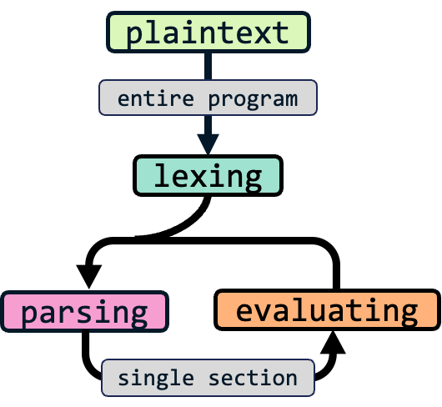Both will split the string they receive on “\n”, to create an array, where each item is a separate line of plaintext in the file. They will also set the have_tokens property to false.

The purpose of have_tokens() is because of how the Interpreter will handle the whole program. It will first translate the entire set of plaintext into tokens, and then evaluate it one line or section at a time. This may not be a pure interpreter, however, as a possible feature to include later will be syntax-highlighting, this will require the plaintext to be Lexed to know how to colour each section. Therefore, have_tokens and storing the result of parsing into a property called tokens reduces the number of times Lexing needs to occur, as if the tokens have already been generated for highlighting, when Run is pressed then parsing and evaluation can immediately begin, without having to inefficiently generate the tokens again.

🡺 make_tokens()

This will be a method for the Interpreter and will call upon the make_tokens() method of a new Lexer with the contents of the plaintext property being passed. If an error is returned, it will be returned, and will otherwise set the tokens property to the 2D array of tokens that is returned, and set have_tokens to true.

### lexer changes

In order to manage positions in the Lexer class, new additions of row and line properties will be added. This will largely mimic position and character but will be on the scale of the entire program. Therefore, row is going to be an Integer, representing position of line, which will be the plaintext at the position of row, within the array of the entire program’s plaintext.

Row and position will both start as -1, and plaintext will be assigned in the constructor.

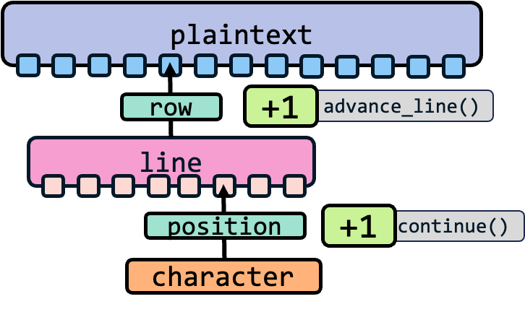🡺 advance_line()

This is the equivalent of continue() for traversing the whole plaintext, incrementing row by one, setting the line to the corresponding plaintext string, then setting position to -1 and calling continue()

When the end of the plaintext has been reached, then line will be set to null.

🡺 make_tokens()

The old make_tokens() will be renamed to make_tokens_line() and make_tokens() will be updated.

It will repeatedly call make_tokens_line() until the current line is null, pushing each result to an array and then calling advance_line(). When it is null, this means there are no more lines, so it will return the array. At any point, if the result from make_tokens_line() is an Error, then this will be returned.

### parser changes

The parser will have very similar system to the Lexer, with the new row and line properties cycling through a tokens property. Tokens will be an array that is passed from the Lexer result. The advance_line() method will also be present, identical to in the Lexer.

🡺 parse_next()

This is the method that will be called by the Interpreter class. It will call advance_line(), and then check if the current line is null. If it is, it returns null, and will otherwise call the parse() method and return that. This is the equivalent of parsing the next section of code and will be called repeatedly until it returns null to represent the end of the program having been reached.

### run

The Interpreter will have a run() method, which will first check if have_tokens is true. If it isn’t, then it will call make_tokens(), **printing out** any potential errors. The key aspect of this run() method is that it is the final level of interaction, so will be outputting rather than returning values.

Then, using a variable called ast, it will repeatedly call parse_next(), setting ast to the result until it is null. This includes checking for Errors and printing them, then calling ast.evaluate(), and checking that result and printing it. If there are any errors, then the loop is stopped by returning out in order to stop the program continuing to execute.

## errors

Errors must also be upgraded to have a line property alongside their position property. This will be defined when they are constructed and passed in as a parameter, so will require a lot of updating of every single instance of a Token being created. The error class will also have to be updated to have a line property, to match the token that is passed.

currentText will also have to be set to match the current plaintext so that Error messages can properly display() the position of the error as expected.

# development: managing multiple lines

## adding lexing to interpreter

The main way I’d like to do this is by using files, so I will implement that feature first.

### A screen shot of a computer program Description automatically generatedopening files

There is no simple way to read the contents of files in JavaScript, so I did some research and ended up using the method at:  
[https://nodejs.dev/en/ledisarn/reading-files-with-nodejs/](https://nodejs.dev/en/learn/reading-files-with-nodejs/)

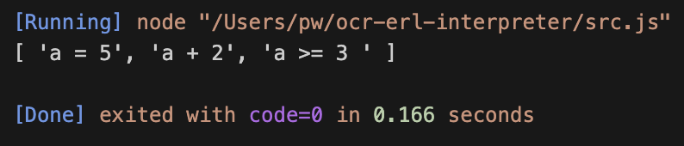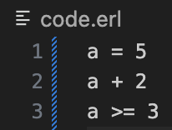Some of the other methods required asynchronous methods, which I thought was a bad idea as I did not understand what it meant. This current method does require a module to be installed by node, however as it is only semi-temporary until the proper interface is introduced later.

As shown, this solution can read a file and save it into an array of the different lines as different items.

### lexer changes

These changes are very similar to the plan.

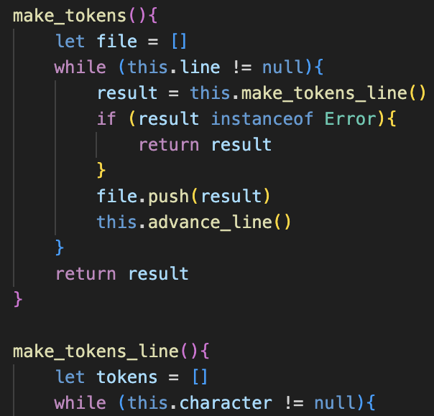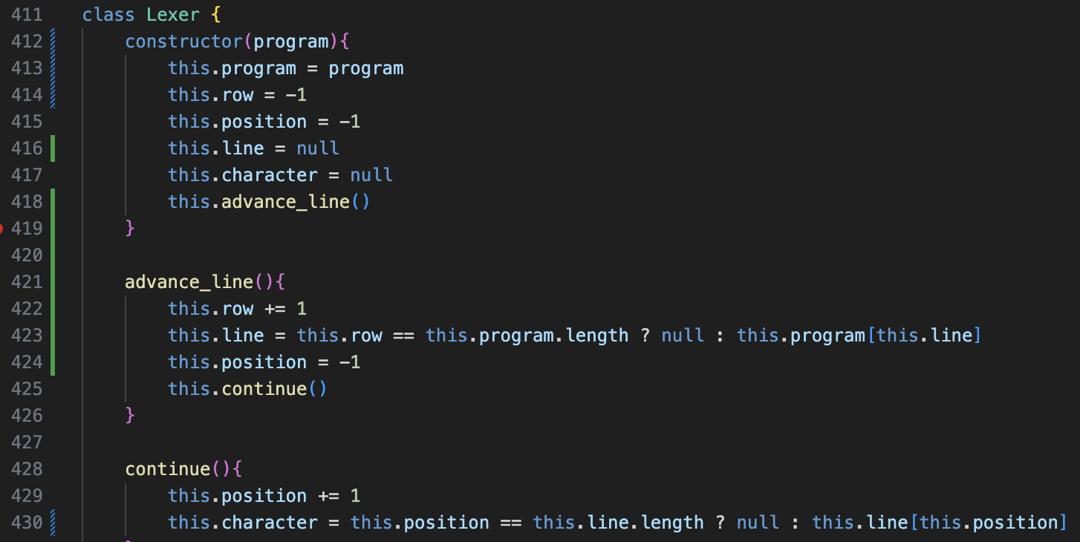 The main difference being that program is used as the property name for the entire plaintext.

File has also been chosen as the array to store the arrays of tokens as a result from make_tokens_line(), which is the renamed old version of make_tokens() for clarity.

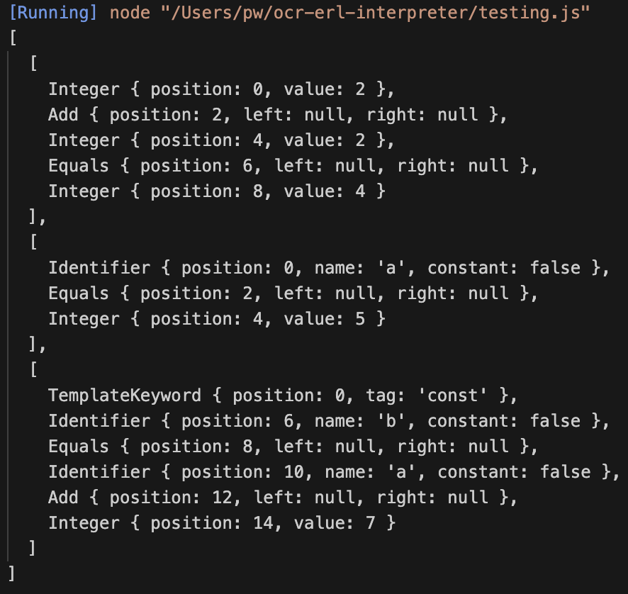As shown, the test case for this worked after a small error correction: the identifiers row and line are very similar so could potentially be changed in the future for less confusing counterparts.

### have_tokens

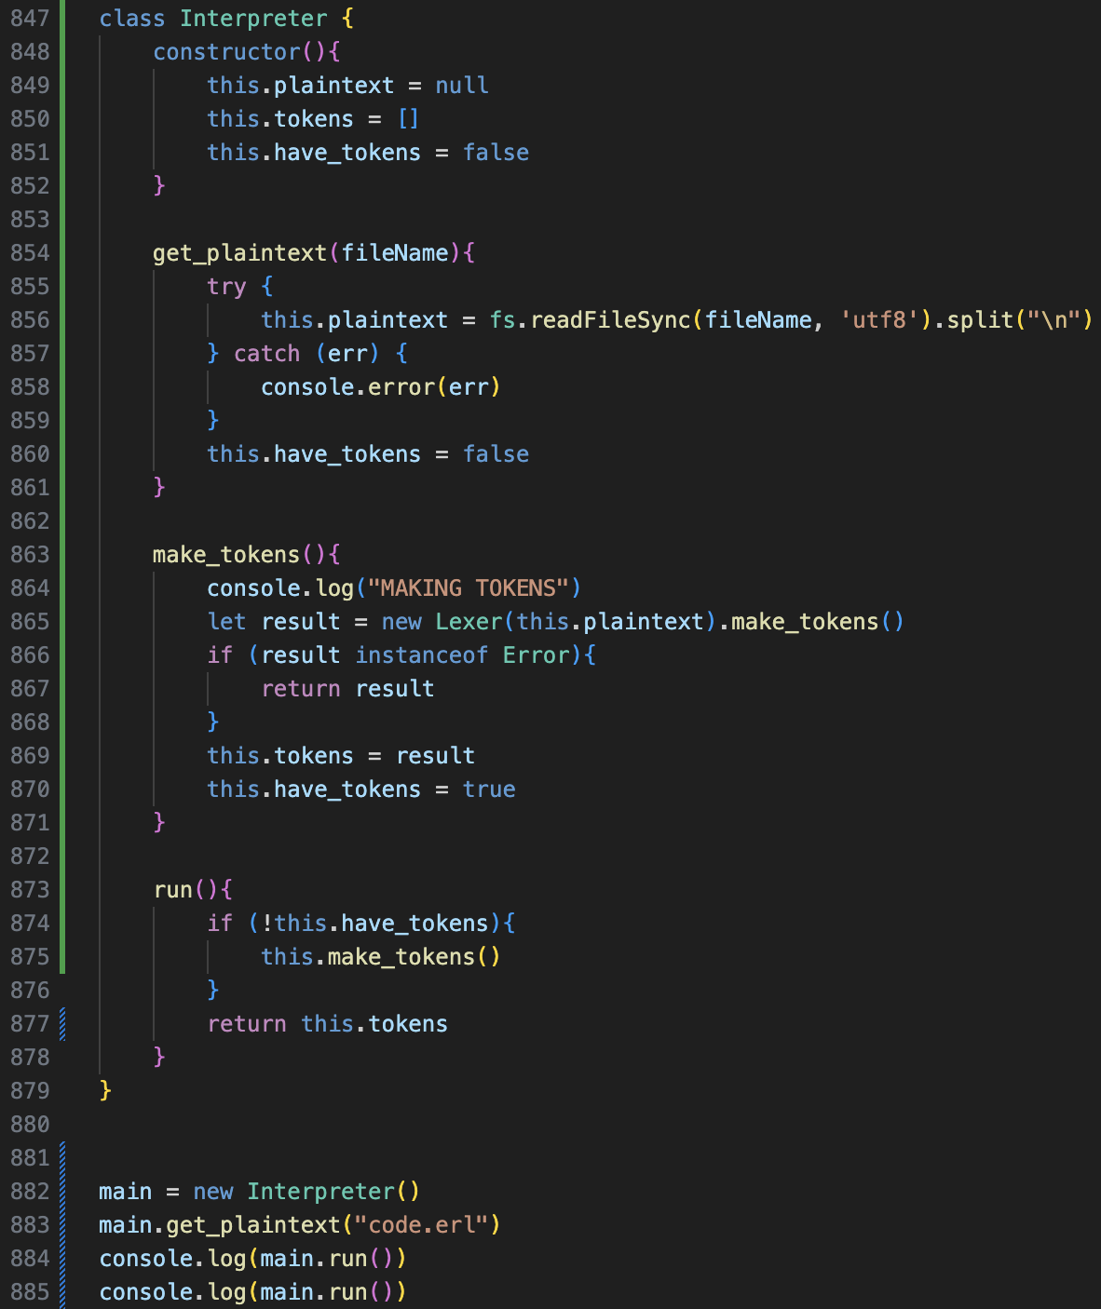On the left is the entire new code for the Interpreter class. This includes changing get_plaintext() to set the result to the plaintext property, rather than returning it.

have_tokens() has been added as expected, and the run() method, for now, returns the tokens, but calls make_tokens() if have_tokens is false: simulating what the future program would do.

As a test, we call run() twice, and see if the temporary “MAKING TOKENS” is only printed once. It is, and therefore the implementation works, increasing efficiency by not re-lexing the entire program on each call of run so long as no changes are made to the plaintext.

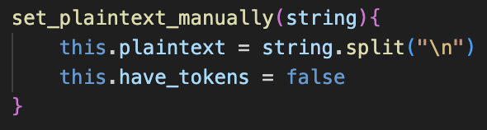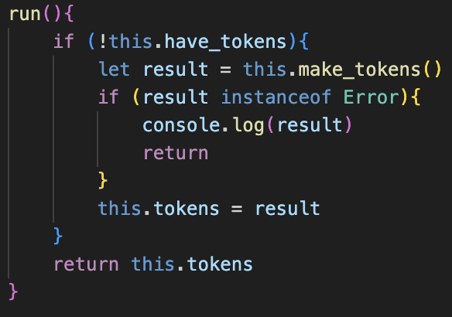run() must also be updated to account for any lexing errors, so that they can be displayed.

A manual plaintext update is also added for easier debugging in the future.

## parser changes

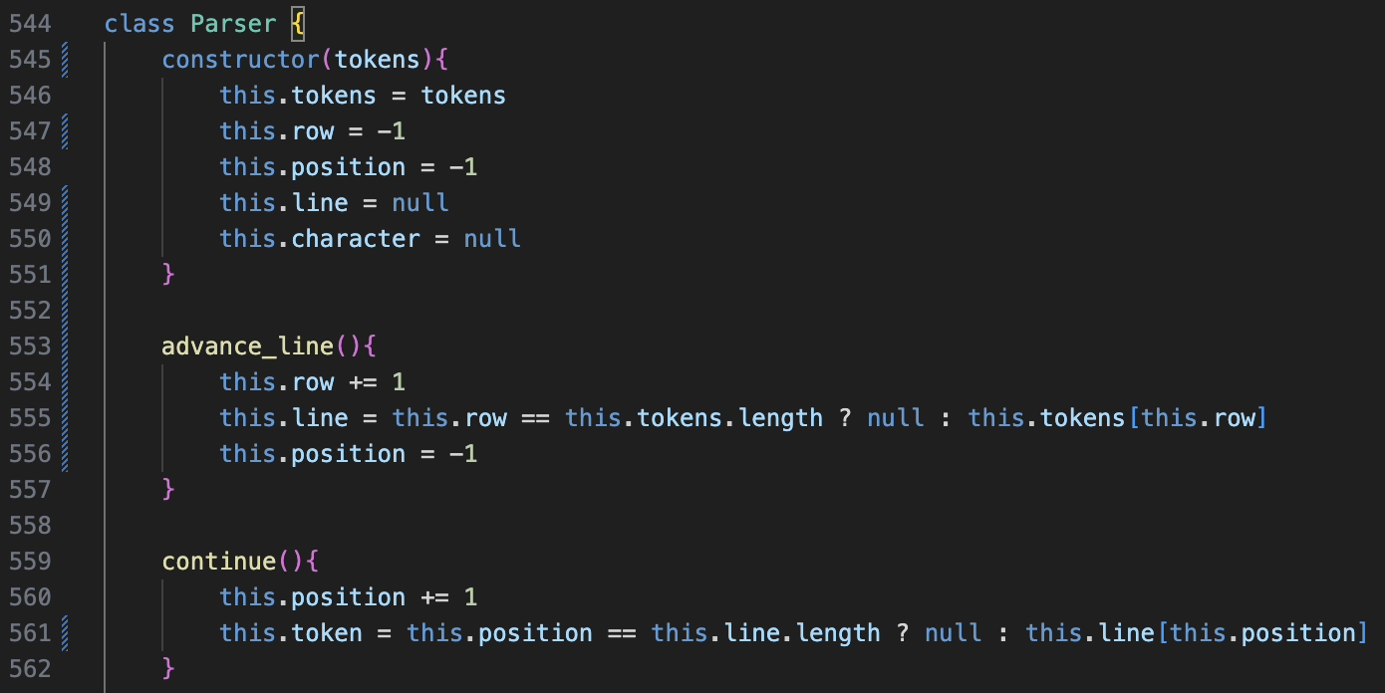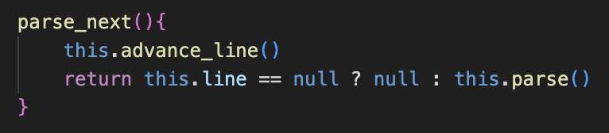The code is a direct copy from the Lexer class, with tokens being the entire set of tokens from the Lexer, which is iterated using advance_line().

parse_next() is also added, to repeatedly call parse(), as described in the plan.

parse_next() is what will be used in the Interpreter code during run() to have an Interpreter style of running a line at a time.

The first attempt of creating the run() method is as shown on the left, which had to be edited to repeatedly change ast to the new value of parse_next() at the end of each iteration.

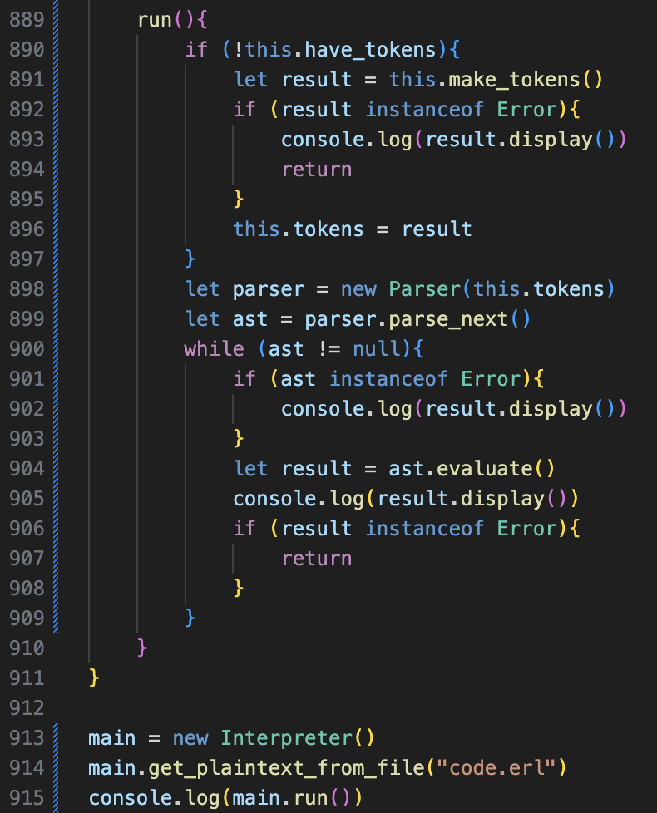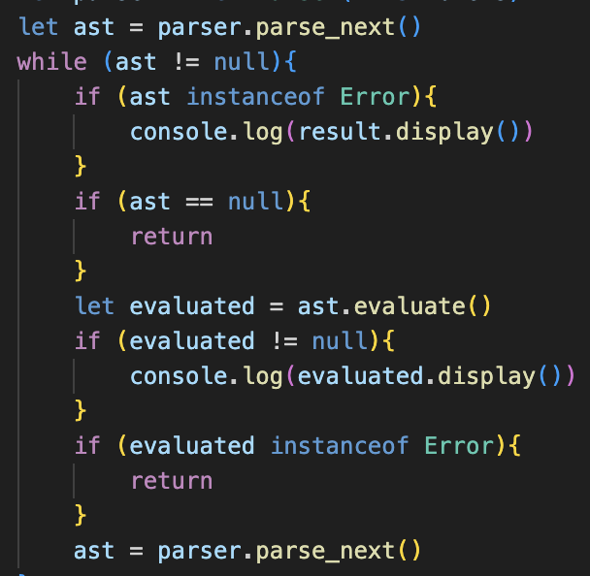

However, there are still several programs with this code when testing and analysing it:

🡺 If the result of evaluate() was null, such as in an assignment, it would cause the program to crash as it would attempt to call null’s display() method.

🡺 Nothing ever gets outputted: the program does not crash but never prints anything.

When debugging by printing out the values of variables, the issue was that continue() is never called after advance_line(), so the token property was always null so nothing was parsed.

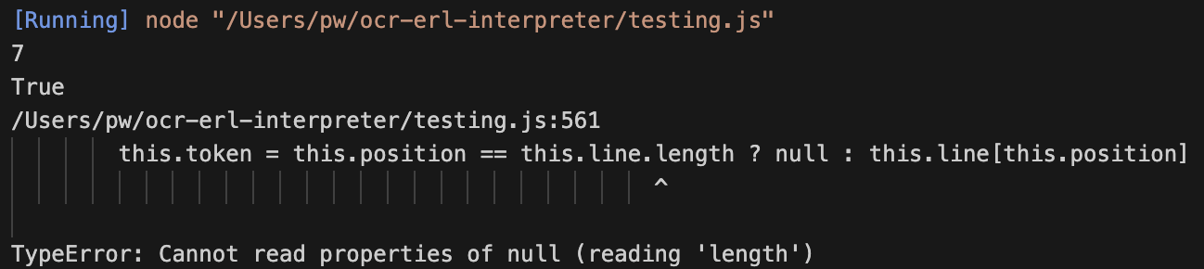A check that line is not null is also required, so that continue() is not called on a null line, which causes an error as shown below.

The updated code is shown below:

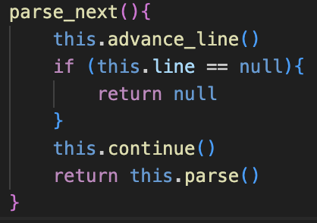  
I changed the name for the result of evaluation to evaluated to make the code more readable, as well as adding the null check.

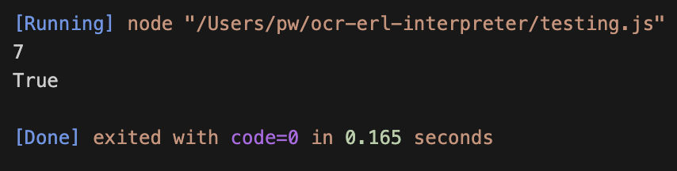When running the test now, the expected result was returned, without the prob gram crashing afterwards.

I ran a few more test cases which were all good too.

### A computer code on a black background Description automatically generatedshell functionality

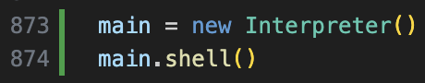This was not on the plan, but adding a shell will be useful for debugging, as well as being an eventual feature to be added. This code works by repeatedly setting the plaintext to a user input, and then calling run() until the exit keyword was entered: “QUIT()”

The shell is called with the code on the left.

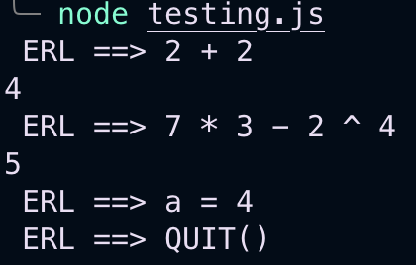As shown on the left, this test case worked as anticipated.

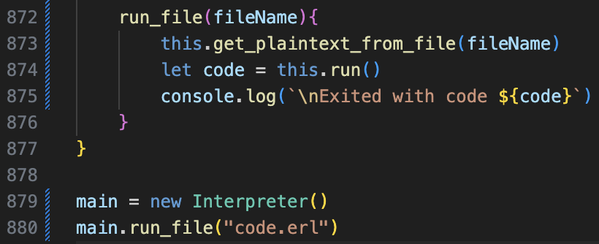I also added a single run_file() method, which combines the multiple steps into one. I also made it print the result of run(), which now has exits codes 0 and 1, typical of programming languages. In run(), now when it is returned due to an error, 1 is passed instead as the return value, and 0 is only returned after the while loop terminates.

This therefore concludes the majority of the multiple-line handling features: now error handling must be reworked as in its current state the program crashes whenever an error occurs.

## error handling for multiple lines

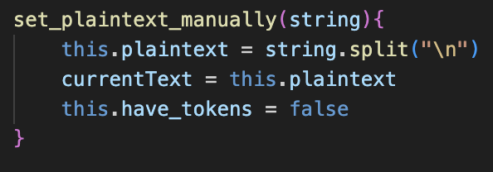To allow errors to access their text, every time the plaintext property is changed, the global variable currentText will be altered to reflect it. This may be changed later, as it is inefficient to save the same data twice.

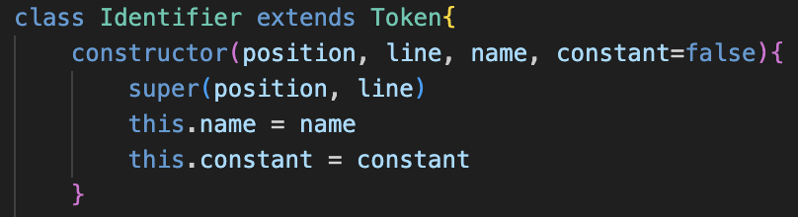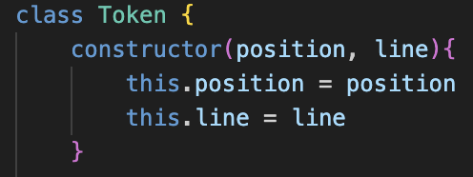Now the line property must be added to Tokens. For consistency, this will always be the second parameter in any constructors, so position then line and then the other parameters.

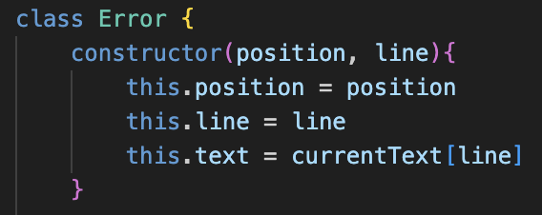Errors work similarly and will have line as their second parameter. Therefore, their text property will be current text at the position of their line property. For Errors that accept tokens in the constructor, the token’s position and line are passed to the super constructor.

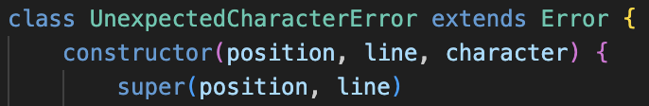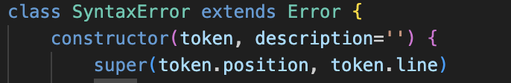

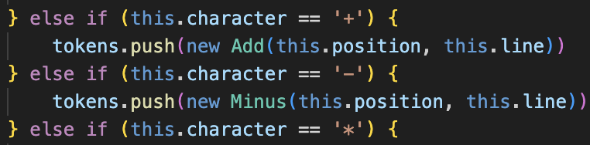From here, every time a new Token (or Character Error) is created in the program, the parameters must be updated to also take in the line. The error’s display() method is also changed to output the line where the error occurred.

### issues with line

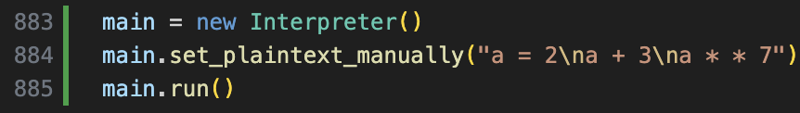The test case on the left was what I used to initially test the changes. The expected result is 5, and then a Syntax Error on line 3.

Initially, the program would not run at all, due to lots of missing line parameters, which was solved by going to the line where the errors occurred in the program and updating them.

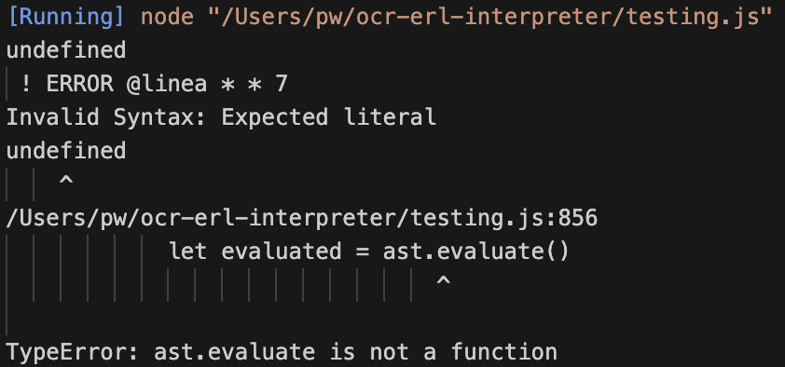From there, the Error message as shown on the left was outputted, and then the program crashed. It is visible from this that the line property of the program, which was meant to be 3, ended up being “a * * 3”, which was the contents of the current line. This was confusing at first, but after looking at the source-code it was due to confusing with my naming conventions.

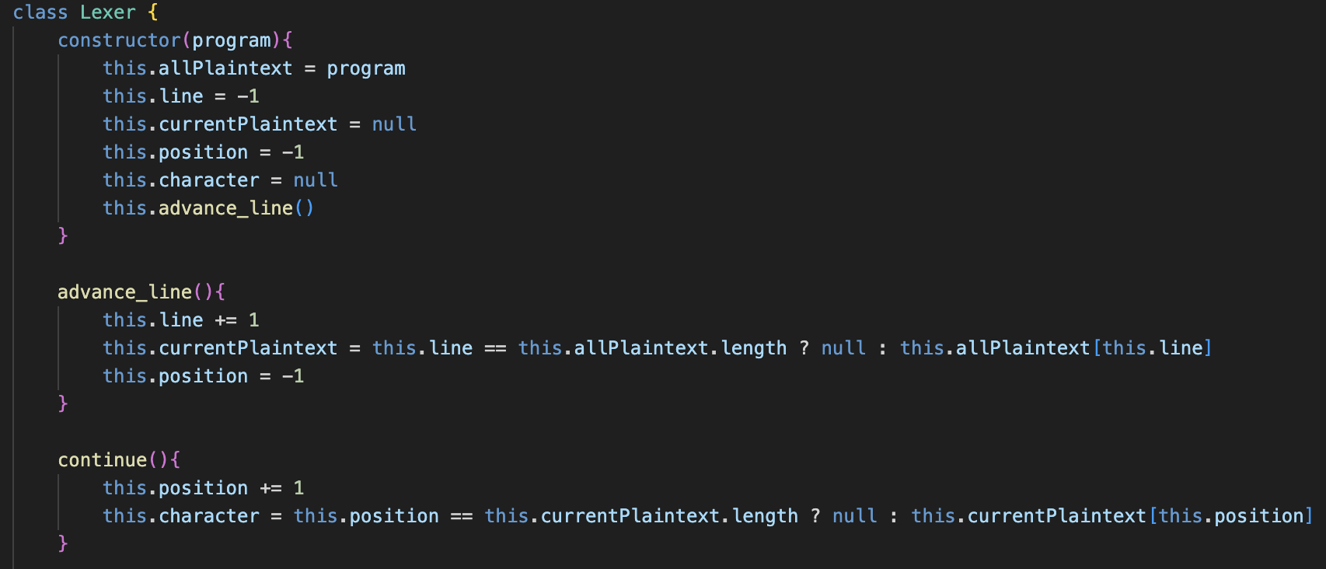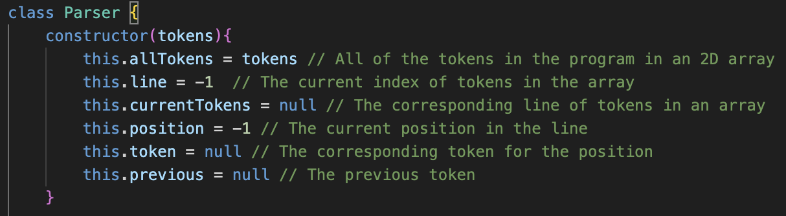In the parser, the property row was the integer, representing the index of the current line, and line was the corresponding contents of that. However, for the tokens, line was now the integer index of the line, and I had passed the string contents into the expected integer property.

The new attribute names are on the left, with line now representing the position value.

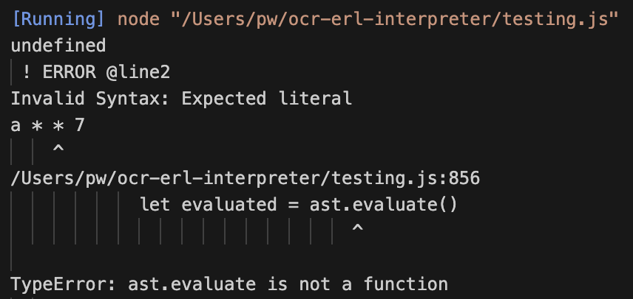The advance_line() and continue() methods also must be updated to reflect these changes, for both the lexer and parser. The make_tokens() and parse_next() methods must also be updated with the new identifiers, which caused numerous errors until the new names were implemented.

The correct line and error message was now displayed, but the values of the previous calculations were not shown. The issues and changes for this were:

🡺 The line property was not passed into the new tokens that were created from arithmetic calculations.  
🡺 If the ast was an error, then it was continued, when it should have been returned with error code 1.

### further errors

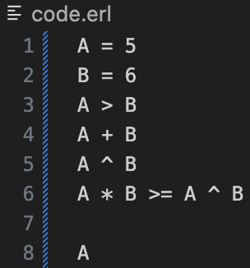The new test case is on the left, and experienced lots of problems.

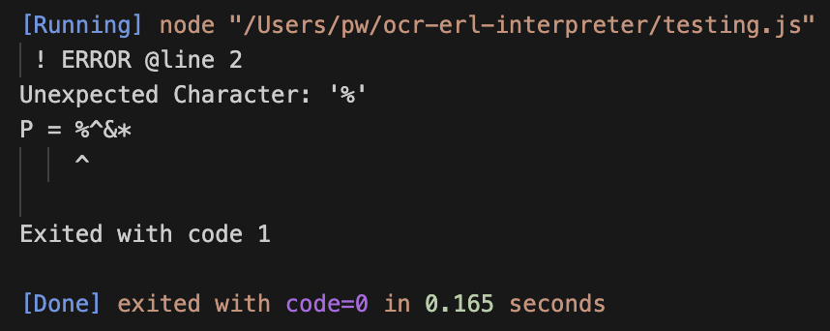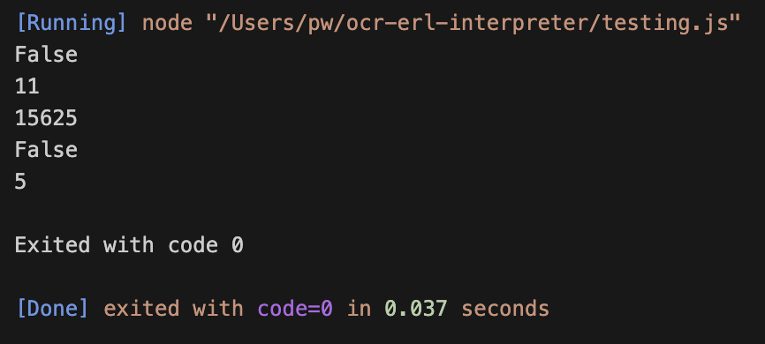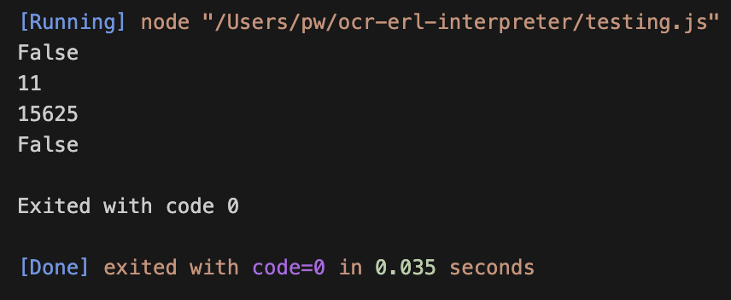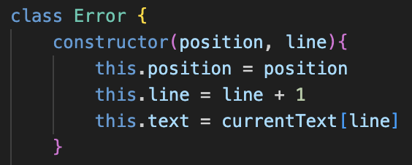🡺 make_logical_operator() had not been updated to include line.  
🡺 The Error class should be updated to print line + 1, as shown.  
🡺 Any empty lines (line 7) would produce a null AST and cause the program to stop prematurely. The fix for this is adding a check in make_tokens(), and if an empty array is attempting to be added to the array of tokens, it is not pushed.

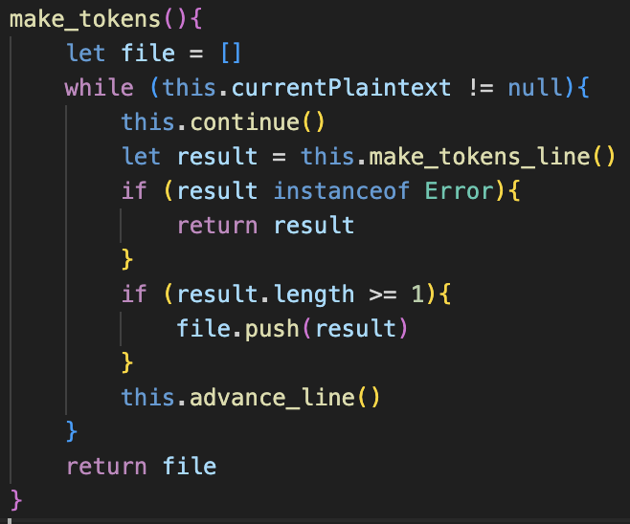The test for Character errors returns correctly.

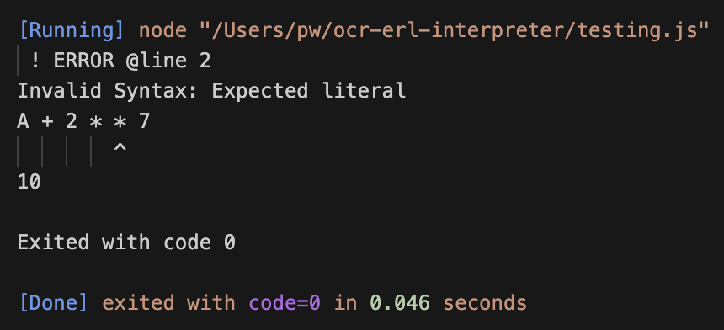

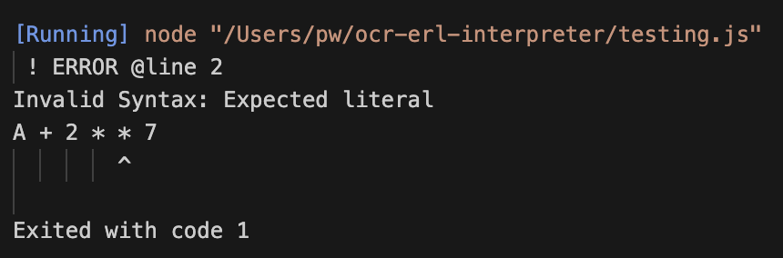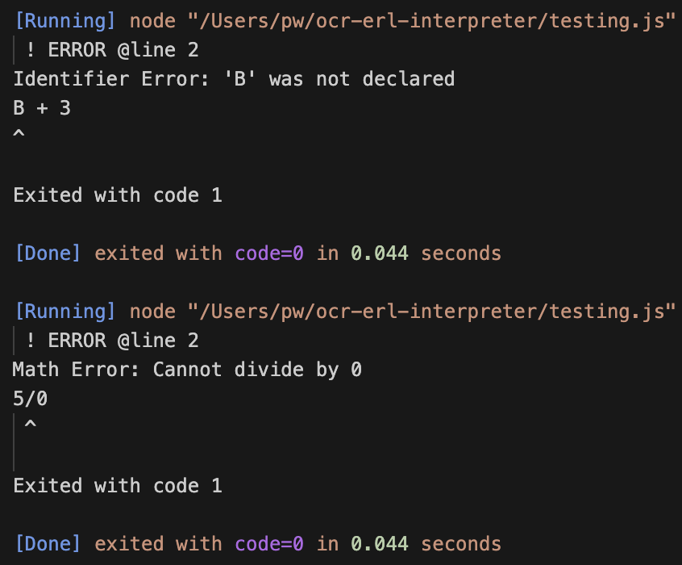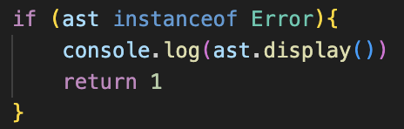Any lines of code after an error would still be executed, when the program should stop, which is fixed by returning out of run()if ast is an instance of an error.

The tests that Identifier Errors and any evaluation errors (such as Math Errors) were successful.

### additional features

Now that the debugging is complete, and the multiple lines can be correctly handled, I wanted to add a few extra features to make this section complete.

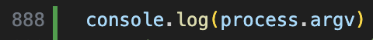Firstly, when trying to streamline the command line experience, I researched how to access the command line arguments in JavaScript and came across the following article:  
<https://www.geeksforgeeks.org/how-to-read-command-line-arguments-in-node-js/>

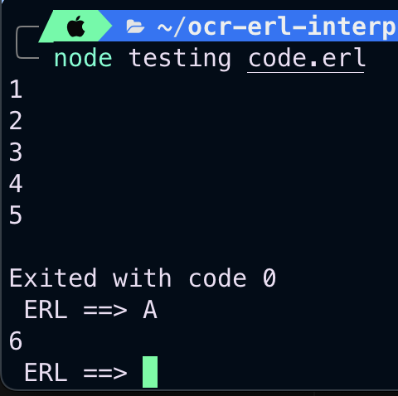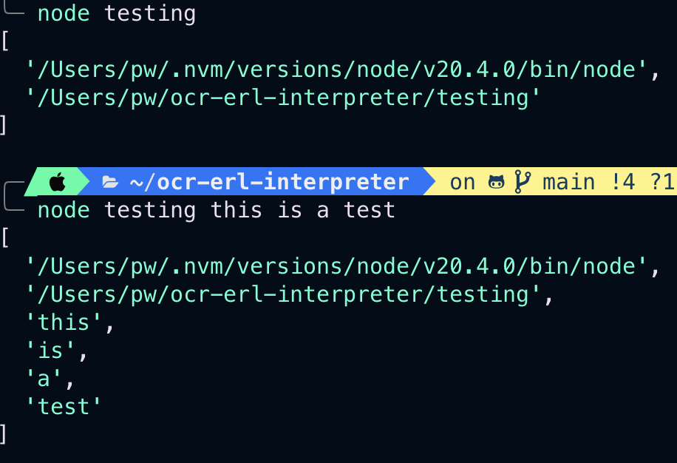When checking how this worked, the first two arguments were to run the file, but any arguments continuing from that werte the custom additions, therefore I could write some code to run the file with the name of the third argument, which would make it a lot easier to run a test the code directly from the terminal.

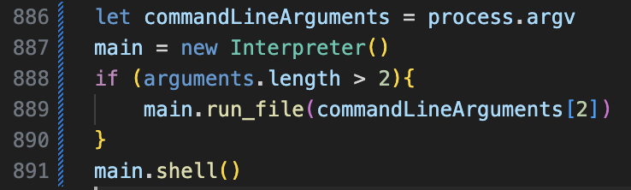I also made it run the shell afterwards to allow for further error checking.

# Design: Implementing if statements

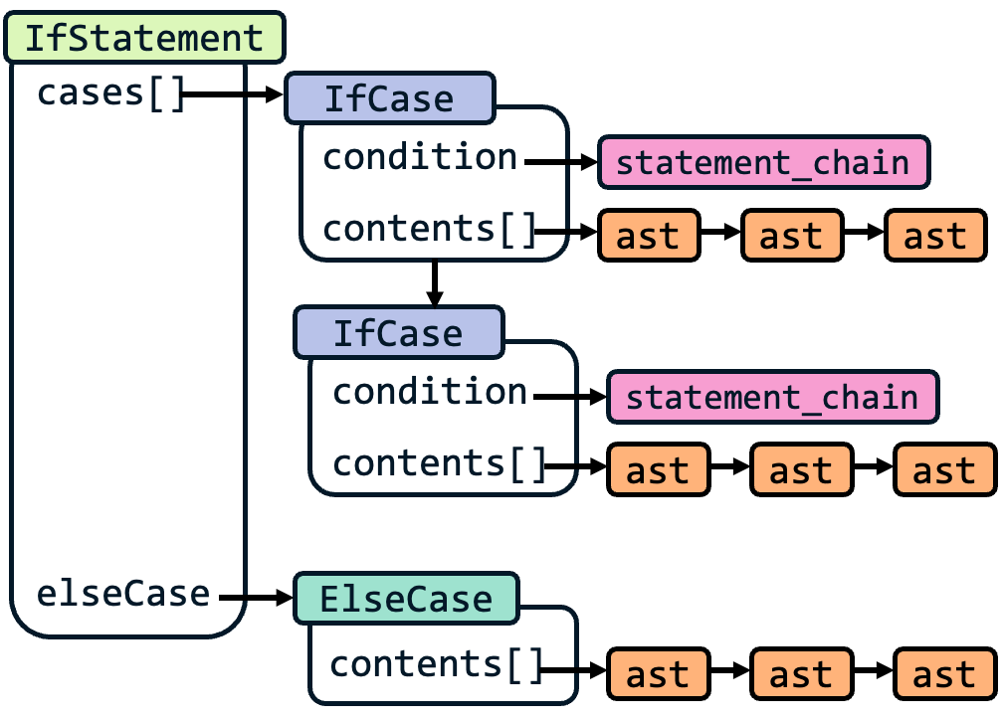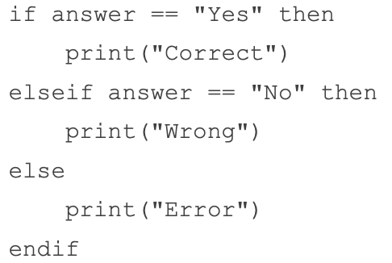If statements are going to be implemented like a custom data type, so it is important to define their structure before considering the coded aspect.

There will be a class called IfStatement, and any instance of this class will represent an entire if chain. Using the OCR specification example, this encapsulates all the code from if to endif.

This will then have two main properties (excluding line and position): an array called cases and elseCase.

The cases array will comprise of a series of objects from the IfCase class. This will represent each branch of the if statement. In terms of the plaintext, each time if or elseif is used, it will be a separate IfCase in the cases array. Each of these IfCases will then contain a condition property: this will be an abstract syntax tree which should evaluate to a Boolean, to represent whether the IfCase should run or not. There will also be a contents array, containing an array of abstract syntax trees for each line of code within the case.

With the OCR specification example, the cases array will contain two IfCases. The first will contain an ast equivalent to answer == “Yes” in the condition property, and the contents array will contain a single ast equivalent to print(“Correct”) . Then the second IfCase will have the “No” check as its condition, and a contents array with length 1 containing the ast for printing “Wrong”.

The elseCase property of IfStatement will either contain null: meaning that else was not used in this if statements; or an instance of ElseCase. ElseCase is very similar to IfCase, but only contains the contents array, and has no condition as it would be automatically run if it is reached. In this case, its contents would be the ast for print(“Error”).

### plaintext to tokens

“if” 🡺 IfStatement: This will always be the first keyword in the entire if statement, however it will also contain its own IfCase, so therefore an IfCase will also need to be made to represent the case.

“elseif” 🡺 IfCase: Each elseif will therefore be one of the cases.

“else” 🡺 ElseCase: obvious.

“then”, “endif” 🡺 TemplateKeyword: These are still very important parts of ERL, but themselves contain no coded functionality, so the template will be used to represent them, as they are still very important to the parser so cannot be excluded.

## code changes

### class changes

A lot of the details of new classes have already been laid out. IfStatement, IfCase and ElseCase will all extend token, and still will have position and line parameters in their constructor methods.

IfCase and ElseCase will not have evaluate() methods, but IfStatement will. However, for clarity it will be called get_case(), as it more clearly explains its purpose and will reduce confusion.

🡺 get_case()

This will iterate through all the IfCases in the cases array. It will call evaluate() on the condition property for each one. If an error occurs, then it will be returned. If it is true, then the contents[] array for that IfCase will be returned. If it isn’t true, then the next IfCase will be iterated to. If the loop completes, the program will check if the elseCase property is null. If it isn’t, the contents of the ElseCase will be returned, otherwise get_case() will represent null, so there will be no ast to execute.

For Lexer changes, make_identifier() is changed so that the switch statement at the end will check for all of the new keywords, and return the corresponding token as described earlier.

### parser changes

🡺 build_if_chain()

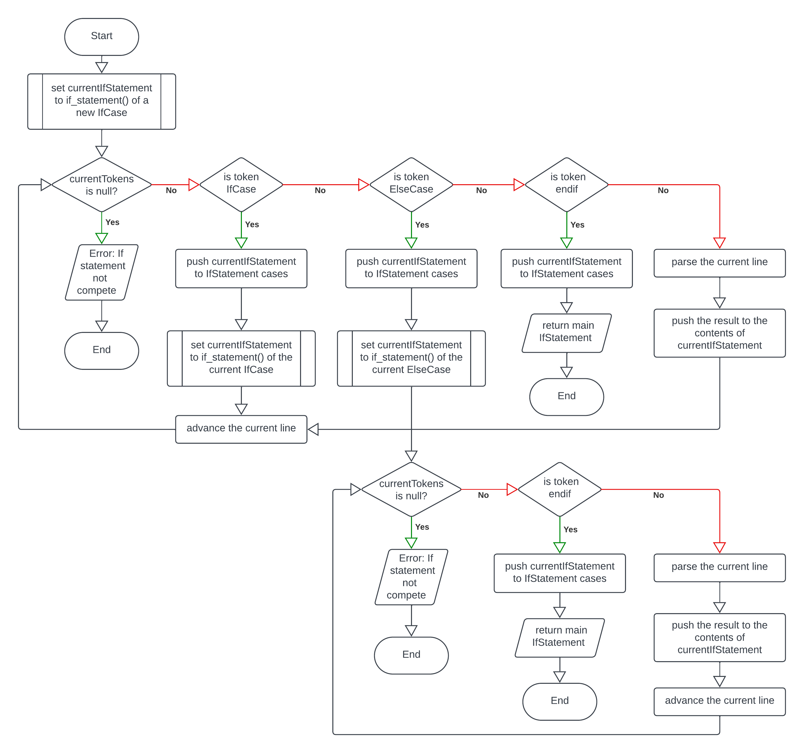This is the main method for constructing IfStatements. It will be called in parse() if the current token is an IfStatement and will construct the entire custom data structure.

currentIfStatement points to the current IfCase, and the default action of the algorithm is to push the current line’s ast to its content. However, if a new IfCase is met, it will become the new currentIfStatement, and will push the old one to the main IfStatement’s cases. Endif will end the loop and will ensure the current IfCase is pushed and then will return the statement as the result.

If ElseCase is encountered, it will lead to a very similar loop, but without the options for IfCases or further ElseCases to occur, as else must be the penultimate keyword before endif.

🡺 if_statement()

This is constantly referred to in the flowchart, and it is the method that deals with the condition lines.

This will have to be able to deal with all the potential errors from invalid inputs.

The BNF for the condition is as follows:  
<if_statement> ::= IfCase <statement_chain> TemplateKeyword:“then”

The method will accept the IfCase token as a parameter: this could have been done by using self.token, however, we need to replace the initial IfStatement with a new IfCase for this method, so accepting it as a method reduces overall code repetition, whilst allowing self.token to be passed for the majority of cases.

### interpreter changes

Now, run() is going to have to be adapted so that it can evaluate an array of ASTs, as that is what calling get_case() will now return.

This means that when parse_next() is called in run(), if the result is an instance of IfStatement, then ast is set to get_case() of that IfStatement, so ast is now an array of different asts.

🡺 evaluate_asts()

To reduce the size of run(), this new method will accept the asts from run() as an argument, and will evaluate() all of them, with the same previous checks that run() had for errors. This method can also accept a single ast that is not an array and will still run it. If an error occurs in this method, it will return 1, and then run() will return 1 if it is received.

This means that, as the feature set expands to include iteration and functions, run() becomes the method that chooses how to acquire the asts, and then evaluate_asts() will accept them and run them.

### error handling

This is a much harder aspect to plan, but error handling is going to be very important in this stage of handling. As the structure becomes more complex, there are lots of different invalid inputs which need to be dealt with, and therefore build_if_statement() and if_statement() are going to have to contain lots of checks to ensure that the input is as expected.

# development: implementing if statements

## building the if statements

### lexer changes

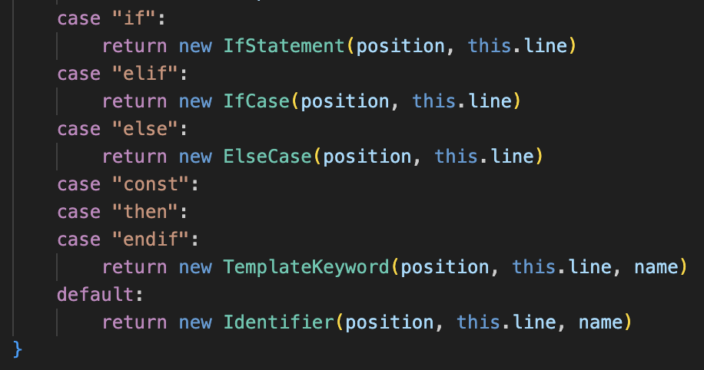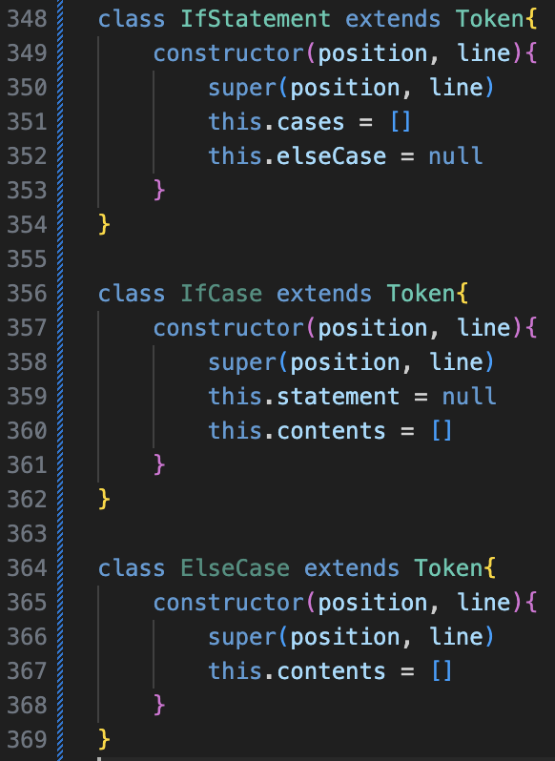Implemented as planned, with changes on the left to make_identifier()

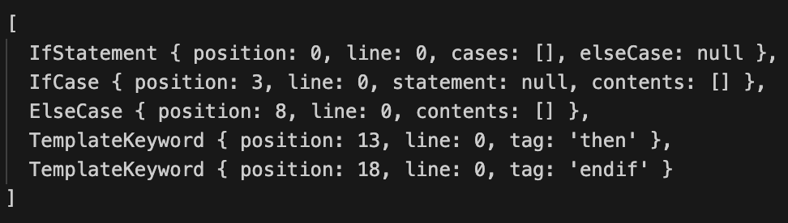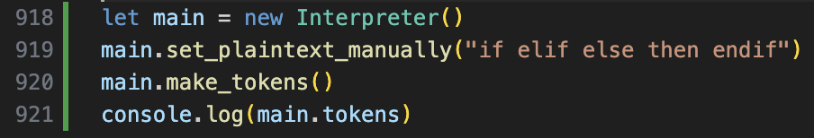Condition is called statement to match statement_chain()

### A black background with colorful text Description automatically generatedif_statement() condition method

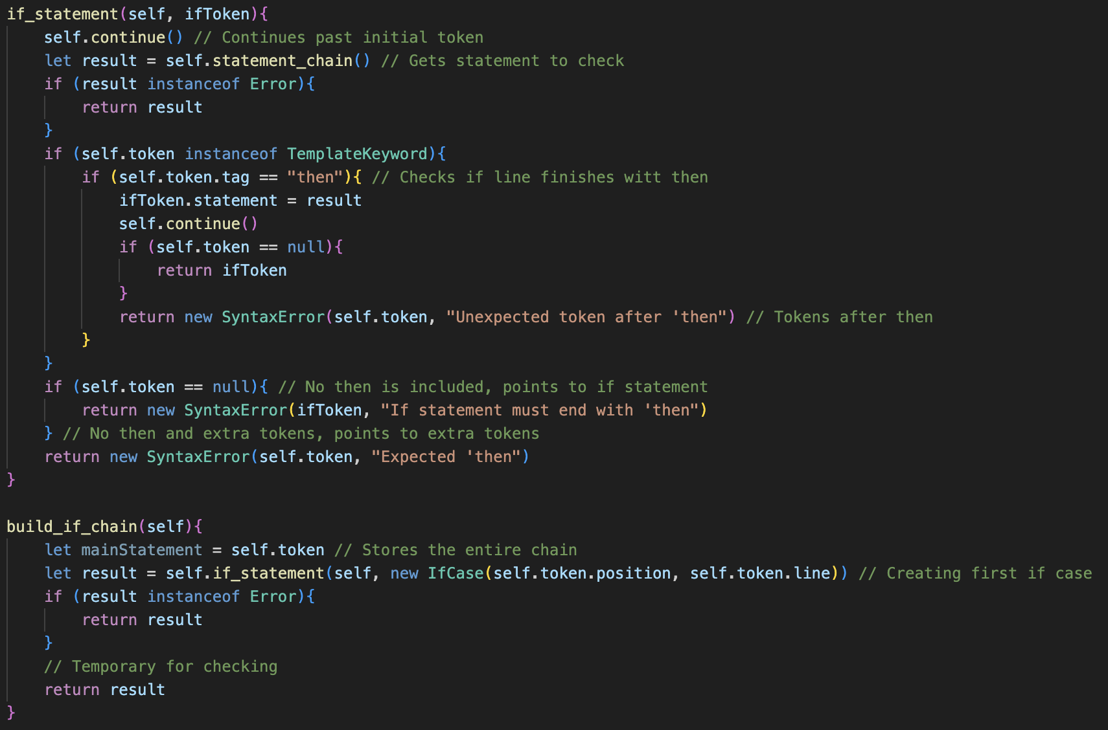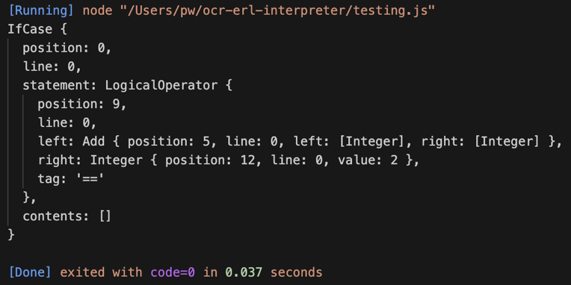

build_if_chain() serves only to test if_statement() here, which successfully passes the testcase, creating an IfCase statement that corresponds with the plaintext input.

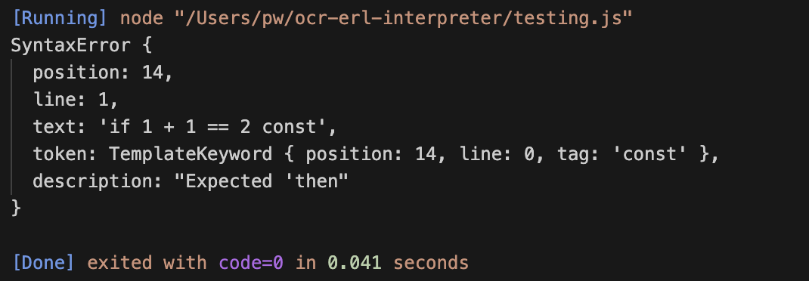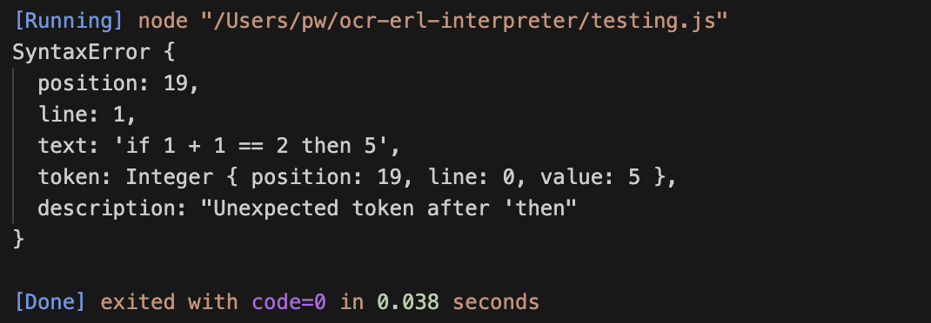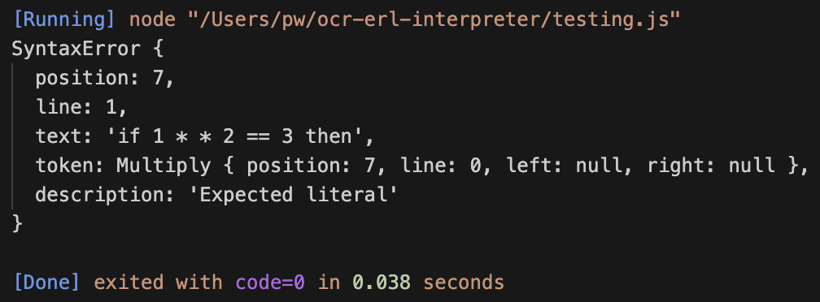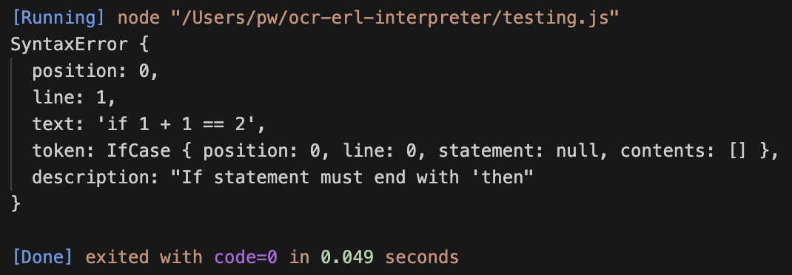ifToken is the parameter that it accepts, and the program calls continue(), then calls statement_chain() to save into ifToken’s statement parameter and ensures that the line ends with a Template Keyword with the tag “then” as specified in ERL. Throughout, I have included multiple Error checks to ensure this layout is followed, with some examples of catches shown below:

### elif and endif cases

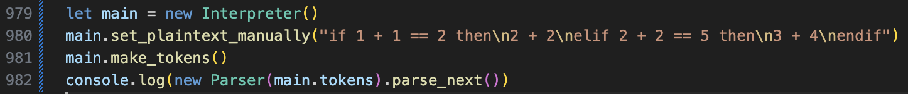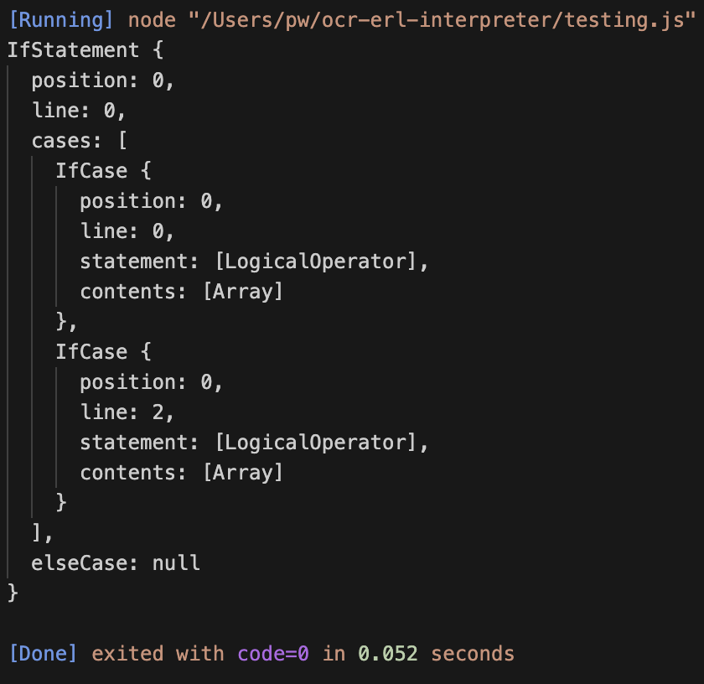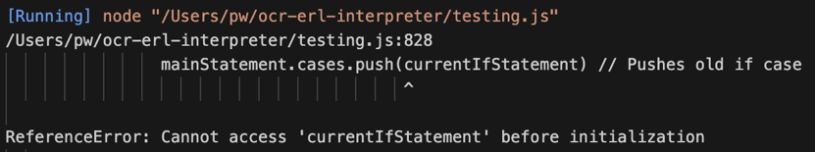I am now going to code build_if_chain(), but only with the default, IfCase and endif branches as they are a lot simpler to implement compared to the elseCase branch.

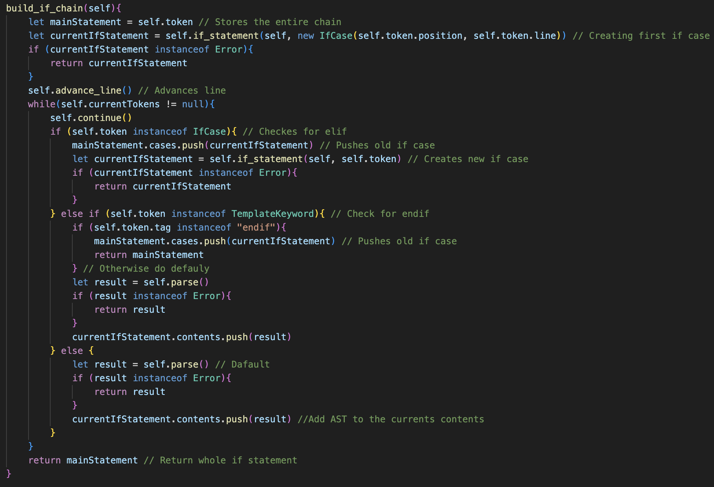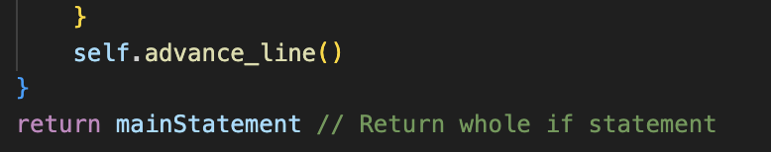

There were a few errors in my initial attempt, which have been fixed and produce the expected result: I have excluded the fully printed out version but the statement and contents are correct, with each IfCase in the contents array having correctly defined attributes.

Currently, the code has some repeated sections, such as the default case being included inside of the Template Keyword check as well in case a Template Keyword was present that was not endif, which is code repetition, but it can be eliminated for a more efficient solution later.

### else case

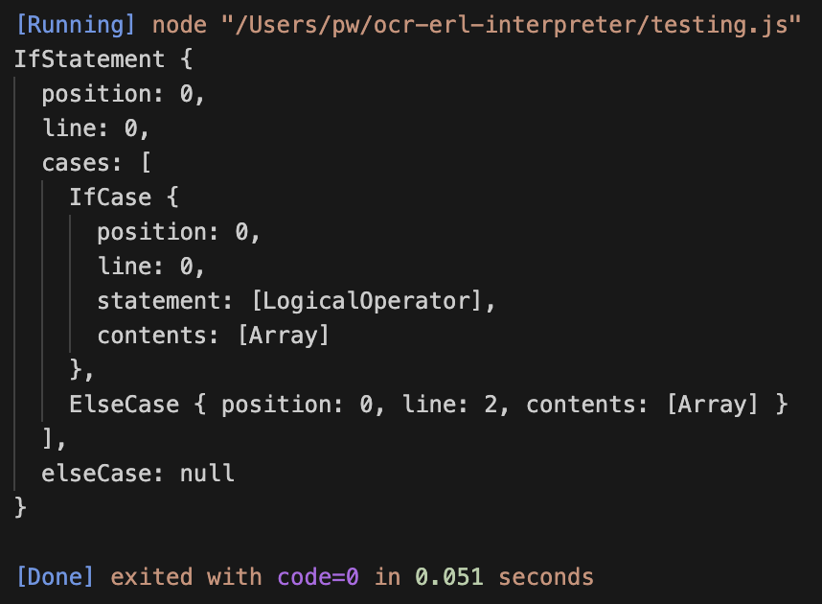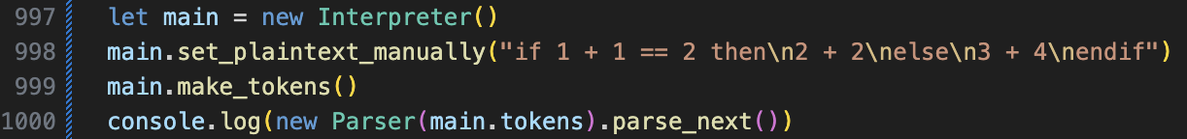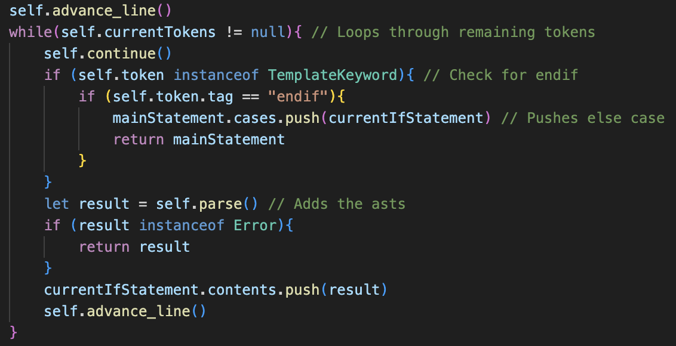This code is after the IfCase check and follows the earlier plan for this stage, however the test case failed.

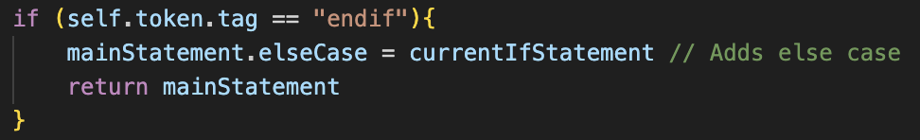This is because the ElseCase was appended to the cases array, rather than to the elseCase property.

This is an easy fix to make, and afterwards the correct arrangement occurred.

This current implementation is good but is missing a lot of error handling for invalid inputs, however I have decided to implement execution before focusing on this.

## A screen shot of a computer program Description automatically generatedA screen shot of a computer program Description automatically generatedA screen shot of a computer program Description automatically generatedexecution

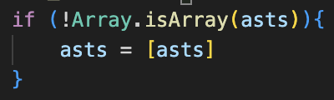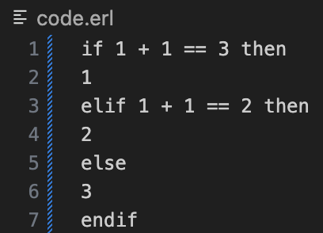This code follows the very loose plan.

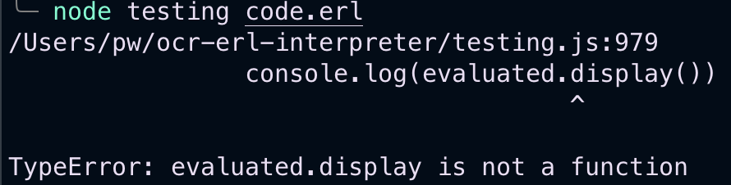The initial error was due to not knowing how to properly check for array, which was easily researched to be fixed.

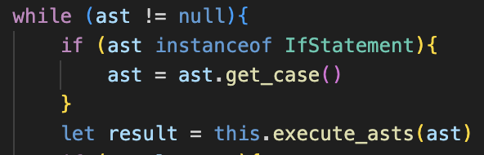The second error was because it was checking for IfCase, instead of IfStatement.

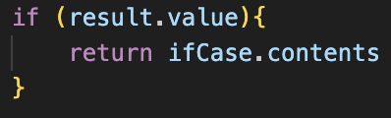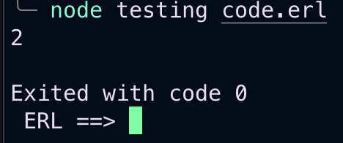Now the program no longer crashed but did not output any result. After further debugging of asts, it was because get_case() returned result.contents, when it should be ifCase.contents, so after this fix, it worked.

### quality of life improvement

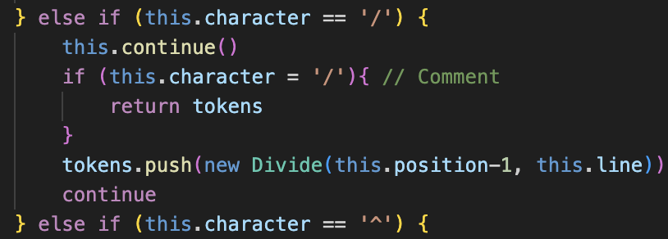Just because my test if statement looked very unclear, I thought it was important to add tabbing and comments quickly. This was changed in make_tokens_line(). Tabs were added by extending the blank space check to include checking for tabs.

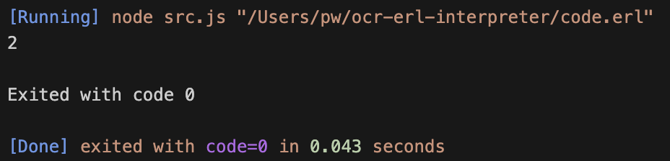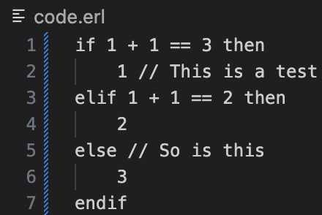Comments were included by extending the divide check, and if the next comment was another slash, then the current contents of tokens would be returned up to this point, as no more code can be written after a comment in ERL.

This now meant that ERL code could become a lot more readable with indentation: however, it is not a required feature and the program still works without it, as many textbooks do not include it and it is important to have consistency with these resources.

## error handling

This section is not as planned but involves me attempting to list every possible invalid input and creating a corresponding error check. I will most likely miss a few, but hopefully when I do more formal testing later, I should be able to catch them and they should be relatively straightforward additions.

Examples will be highlighted in red beneath the subtitle, as they would currently crash the program or produce a false error, and the implemented fix will be unhighlighted.

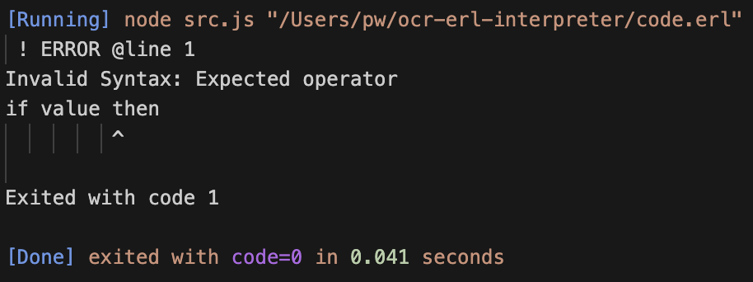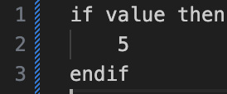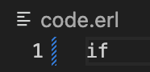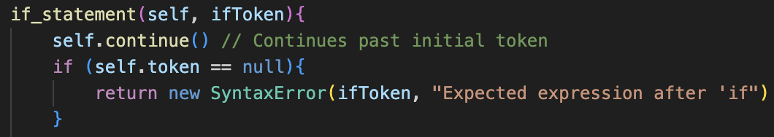🡺 **A lone “if”** Ensures that the next token is not null after the first if token, returning a custom error message  
**🡺 Using an undeclared Identifier in the condition**

This currently does not crash the program, but returns the incorrect error message, and this is due to how half_statement() operates with Identifier.

In the logic chapter, I commented that I did not like the evaluate() check to ensure that Identifiers are Booleans to allow a half_statement to be defined. This now causes problems further down the line, and the solution is to reduce the strictness of half_statement().

This involves removing the check for Identifiers, and that if no Logical Operator is present after the left-hand side, then it is returned. This does therefore mean, that statement() may potentially not always return a Boolean value. This does mean that extra checking is required elsewhere in the program to ensure the datatypes are as expected. This will be added more in depth later on, in the strings section for watertight type handling, however for now there may be some edge cases which break the program.

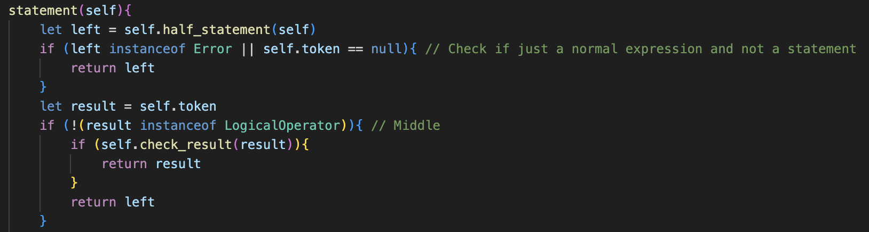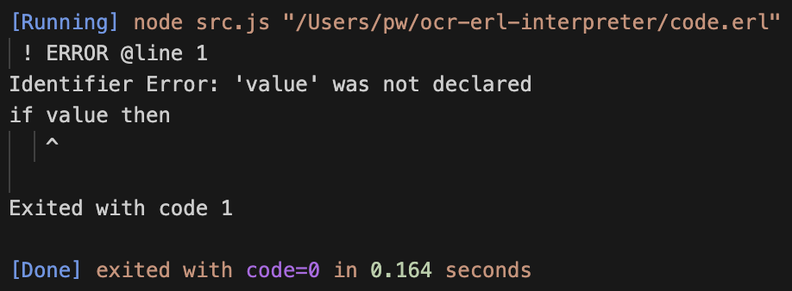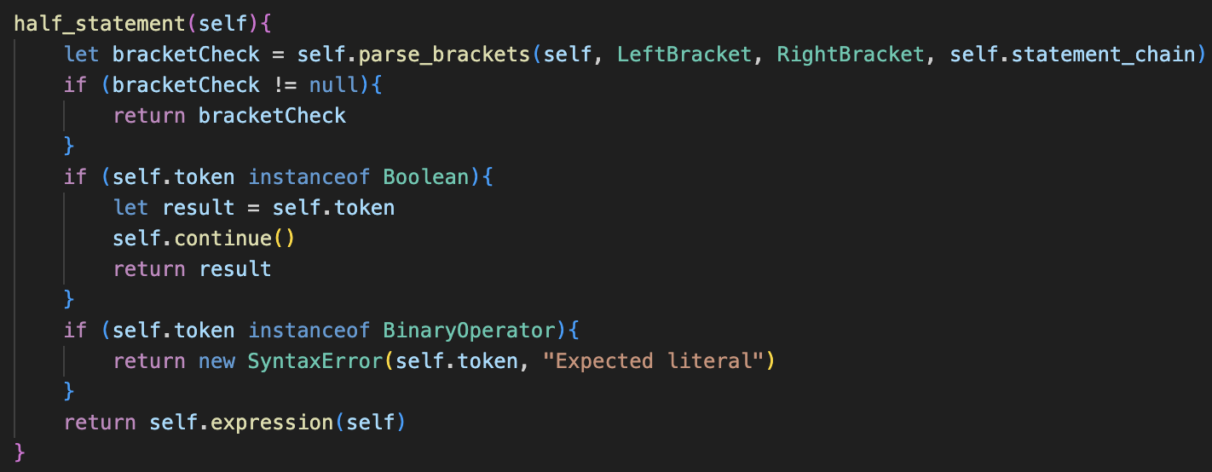The new methods:

The correct error message is now returned by the program; that the Identifier has not been defined.

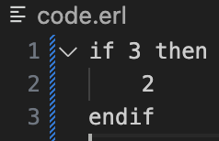**🡺 Non-Boolean condition**

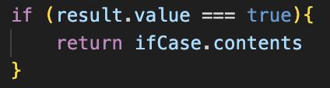Now that non-Booleans can be returned from statement_chain(), the strong comparison operator must be used in get_case() to ensure the value is a boolean, as JavaScript evaluates true == 3 to true.

A small syntax error was corrected, as elseCase was used rather than this.elseCase, and then this fix worked.

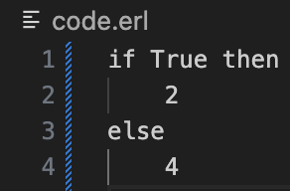**🡺 No endif at end of if statement**

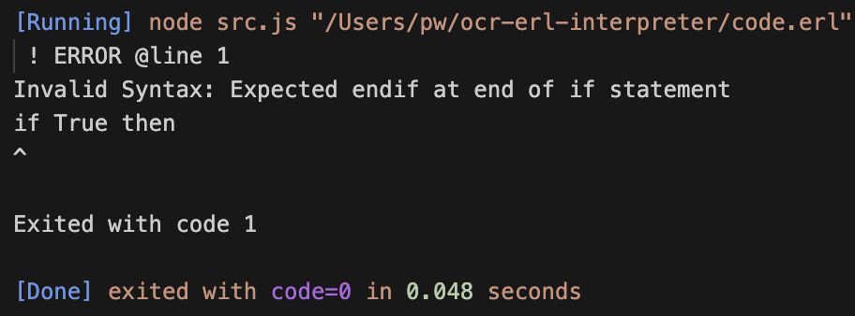The fix for this was already implemented, but it contained a small syntax error which has now been fixed, alongside an improved error message.

I do not love that the error points to the if, as the issue is that the if statement is not closed and the start seems very far away from this, however it seems to be the most logical option so I chose it for the error token.

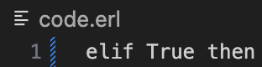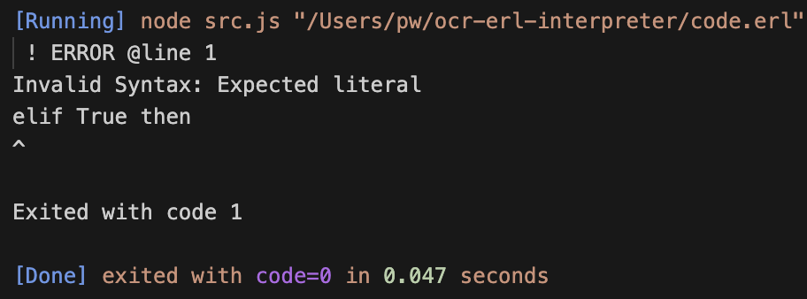**🡺 Random elif or else statements.**

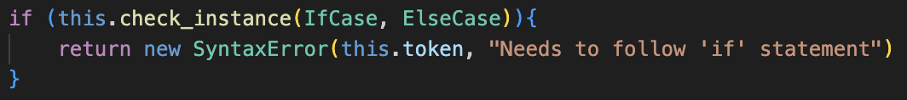The program technically can catch this error; however, the error message is not very representative of the issue.

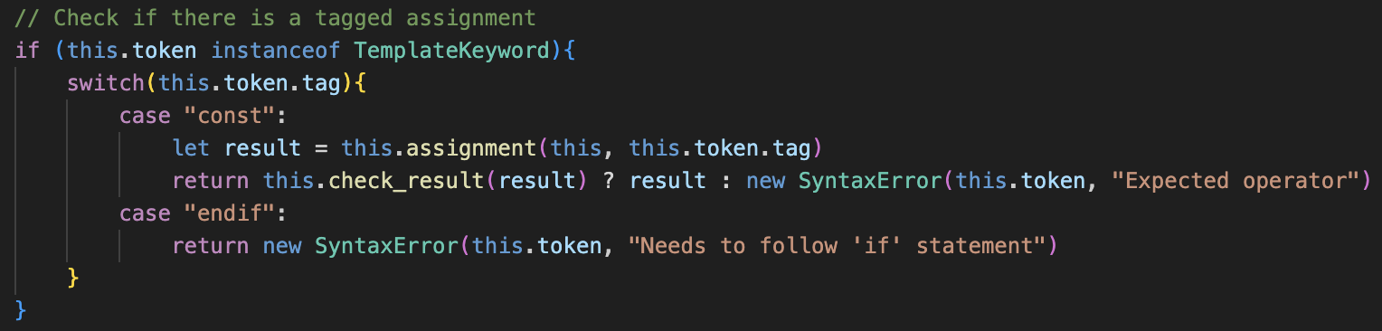The fix is to add a check in parse(), and if the first token in a line is an instance of IfCase or ElseCase, then a custom Syntax Error is returned.

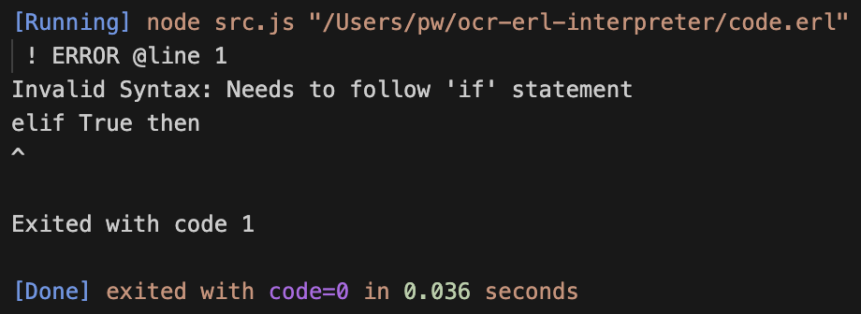I also did the same check for “endif” tagged Template Keywords in parse(),

The resulting error message on the right is now much clearer and more representative of the issue than “Expected literal”

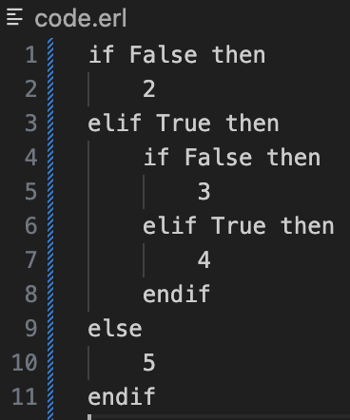🡺 **Nested if statements**

Although this is a completely valid input, the program currently crashes when attempting to run a nested if statement.

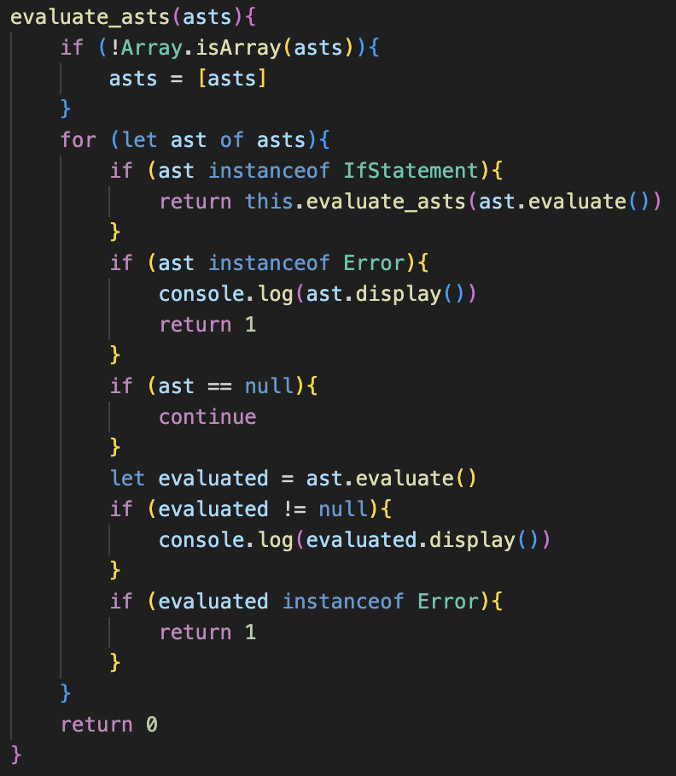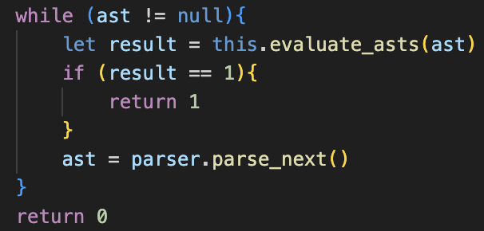This requires a redesign of run() and evaluate_asts() in the Interpreter class, to allow evaluate_asts() to recursively call itself. For this, I decided to rename IfStatement’s get_case() to evaluate() for consistency and reduction of code repetition. Even thought it was a deliberate decision earlier to uniquely identify the method, it seems that in the long term it should be better, as loops will also have a similar system and each type having a customised evaluate() call avoids using polymorphism which is a very strong and useful aspect of OOP. This change just requires a few naming changes.

The update moves the checks from run() to evaluate_asts(), so that an IfStatement can then continually call further IfStatements by more of these checks. Therefore, each layer of if statement will run a new instance of evaluate_asts(). run() now serves as only the base of the program: creating tokens and calling the initial evaluate_asts(), but all evaluation has now been moved.

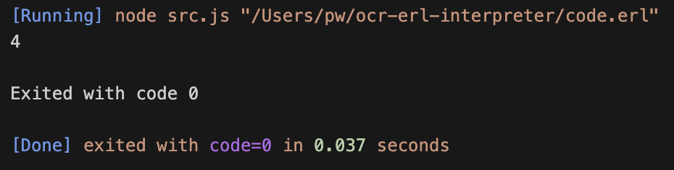This now works as anticipated, and the program produces the correct results. Because of the dynamic implementation, the system will work for any amount of nested if statements as well and allows expansion for other structures in the future.

### final changes

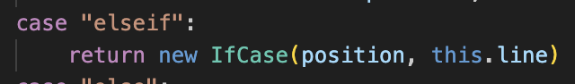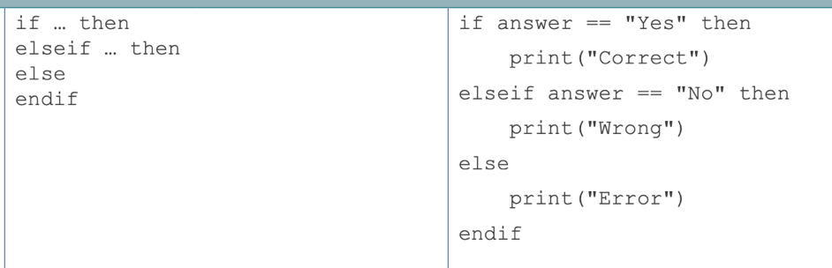Stupidly, I have been using “elif” instead of “elseif” like the specification states, but this is a very easy change, just requiring a string in make_identifier() to be altered.

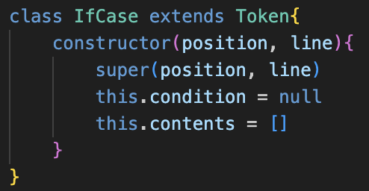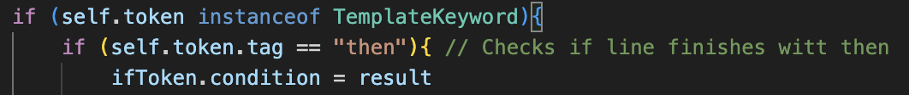Finally, I did not like that IfCase’s condition is called statement, so I decided to change the attribute name. This required changing some of the code in other places, but some testing showed that it still worked.

This concludes the code for if statements.

# evaluation

The result of the success criteria for this section are as followed:

|  |  |  |
| --- | --- | --- |
| No. | Criteria | Implemented? |
| 4.1 | Allow if statements to be created by the keyword “if”, followed by a condition and “then”, then containing the code for that case, and closed by the closing keyword endif | Badge Tick with solid fillCompleted |
| 4.2 | Allow additional cases to be added using “elseif”, followed by a condition and “then”, followed by the corresponding code for that case before another “elseif” or “endif”. | Badge Tick with solid fillCompleted |
| 4.3 | Allow a final default case to be added, by just the keyword “else” on a line by itself, followed by the corresponding code for that case, evaluated if no other conditions are True | Badge Tick with solid fillCompleted |
| 4.4 | Ensure that the order of the cases are regulated: always started by if, followed by elseif, then an optional else, then endif | Badge Tick with solid fillCompleted |
| 4.5 | Ensure that the correct syntax is perfectly followed, giving detailed feedback about missing keywords so that it matches the specification exactly, as well as only valid conditions. | Badge Tick with solid fillCompleted |

I feel that this section has gone very well, and the new Interpreter class is a good new system to merge the different elements, however, could probably do with a slight redesign as I’m not sure how it will cope with the new Loop features.

I do also feel that some error messages for invalid conditions could be implemented, as currently if a condition is an integer value, it will just ignore the case and pass over it and an error would be better. I feel like adding this in module 6 will be good as that is where types will become stricter.